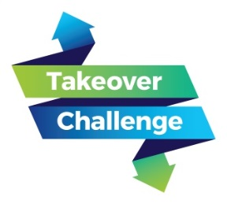
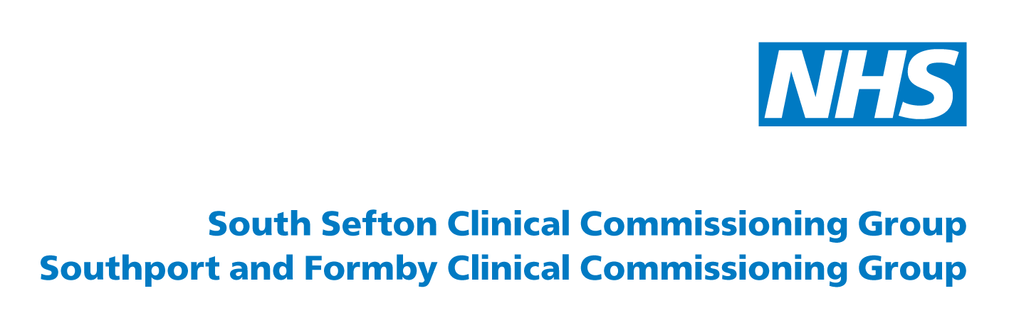

Young people’s engagement event
Summary report
November 2016

NHS Southport and Formby CCG
NHS South Sefton CCG

Contents

About the engagement event | 4
How the event worked | 5
What people told us | 6
Key themes from workshop discussions | 8
Summary / next steps | 12
Get involved or find out more | 13

About the engagement event
Young Advisors from Sefton Council for Voluntary Service (CVS) took control of the clinical commissioning groups’ (CCGs’) joint Engagement and Patient Experience Group (EPEG) on 18 November 2016 to mark the launch of the Children’s Commissioner for England’s Takeover Challenge.
The Takeover Challenge is an engagement project which sees organisations across England opening their doors to children and young people to take over adult roles.
It puts children and young people in decision-making positions and encourages organisations and businesses to hear their views. Children gain an insight into the adult world and organisations benefit from a fresh perspective about their work.
Six young people from Sefton Young Advisors led the meeting and took over the CCGs’ twitter accounts to engage with CCG staff and key partners in order to discuss the best ways to engage with young people.
The aims of the session were to develop ideas and plans for how we can work more constructively with vulnerable young people going forward.

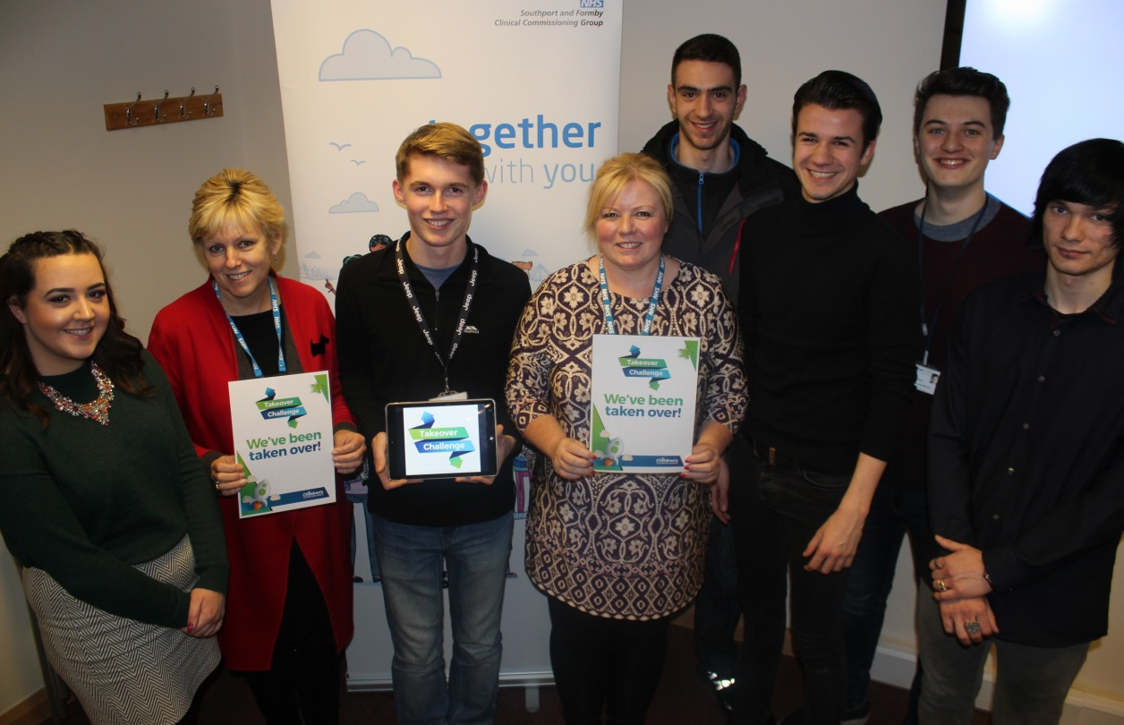

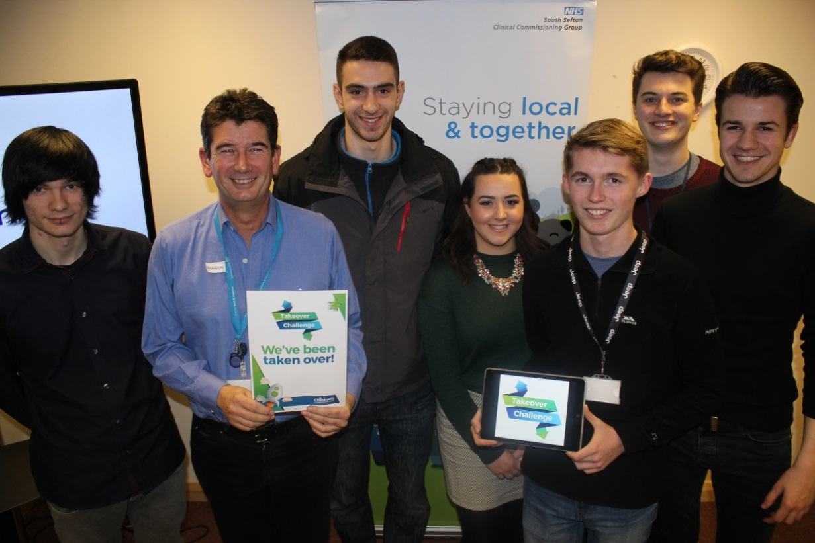
How the event worked
Jo Herndlhofer, the CCGs’ communications and engagement officer, opened the event by introducing the young people to the EPEG group.
Gill Brown, head of the patient experience group and lay member for NHS Southport and Formby CCG then spoke about the takeover challenge and explained that the CCGs’ were keen for young people to take over the meeting as it’s all about engaging with the public and the best way to do this.
Ryan from Sefton Young Advisors talked about the group, explaining that it is a national charity and that it is seen as the bridge between young people and key decision makers. The young people are paid professionals and their job is to advise and help organisations in engaging with the younger, more vulnerable generation.
They also do what is called ‘youth proofing’ for many local organisations by consulting on materials that may be too full of jargon. They also take part in mystery shopping of public services and they worked with Sefton Council on the consultation of its Imagine Sefton 2030 campaign.
The session included an ice breaker to lighten the mood and get people to know one another then a workshop took place to discuss what emotional health and wellbeing means to young people. Factors were discussed that could affect a young person’s emotional health in positive and negative ways.
Defining the important services to young people was also discussed and how services can be better accessed by young people.

What people told us
Sefton Young Advisors shared their top 10 tips for involving young people with the group:
1. Was it young person led?
Were young people involved from the start of the process, helping to plan and lead activities?
2. Support
Was support provided to the young people as and when they needed it?
3. Appropriate training
Did the training provided for the adults and young people give them the skills and knowledge to enable them to work together?
4. Lead person with responsibility for young people
Was someone identified in the organisation who young people knew they could go to for information and who would get things done?
5. Never assume!
Were young people asked for their opinions and ideas before any actions were taken?
6. Keep young people informed
Did someone make sure young people knew what was happening, even if it was not what they might have wanted to hear?
7. Inclusion
Were as many young people involved as possible? Working with the same young people can keep other young people away.
8. Incentives and rewards
What was in it for them to participate? Sometimes a thank you may be all that is required.
9. No jargon
Was young person friendly language used, and acronyms avoided or explained? For example, NEET’s, CAF, ECM, CSE, LSCB, LAC, JSNA, CCG, PACTs…
10. Fun?
What’s the point if it’s not fun?

The young advisors explained that a consultation exercise will be carried out in March on emotional health and wellbeing when a Q&A with young people and service professionals will take place.
Caroline Scott from Camhelions, a young people’s voluntary group, showed a presentation from a conference on why creativity works. The video is very light hearted and clearly works to informally explain how young people can benefit from services and on how they would like to be engaged with. It aims to break down the barrier between adults and young people with a few ideas on how to do so.
The video can be viewed here: www.vimeo.com/159070184
The animation posed some questions for the guests at the event, one of which was:
Q: Have the recommendations in the video been acted on yet?
A: Not all of them but the majority of recommendations were a few years ago now and the services have improved greatly since then. Young people are asked about services on a regular basis. Mersey Care NHS Foundation Trust is looking at increasing participation of young people across the board and Alder Hey is doing the same. Things like not having a desk between people can make a huge difference and this has been acted on, taking out the barrier to create a more informal environment.
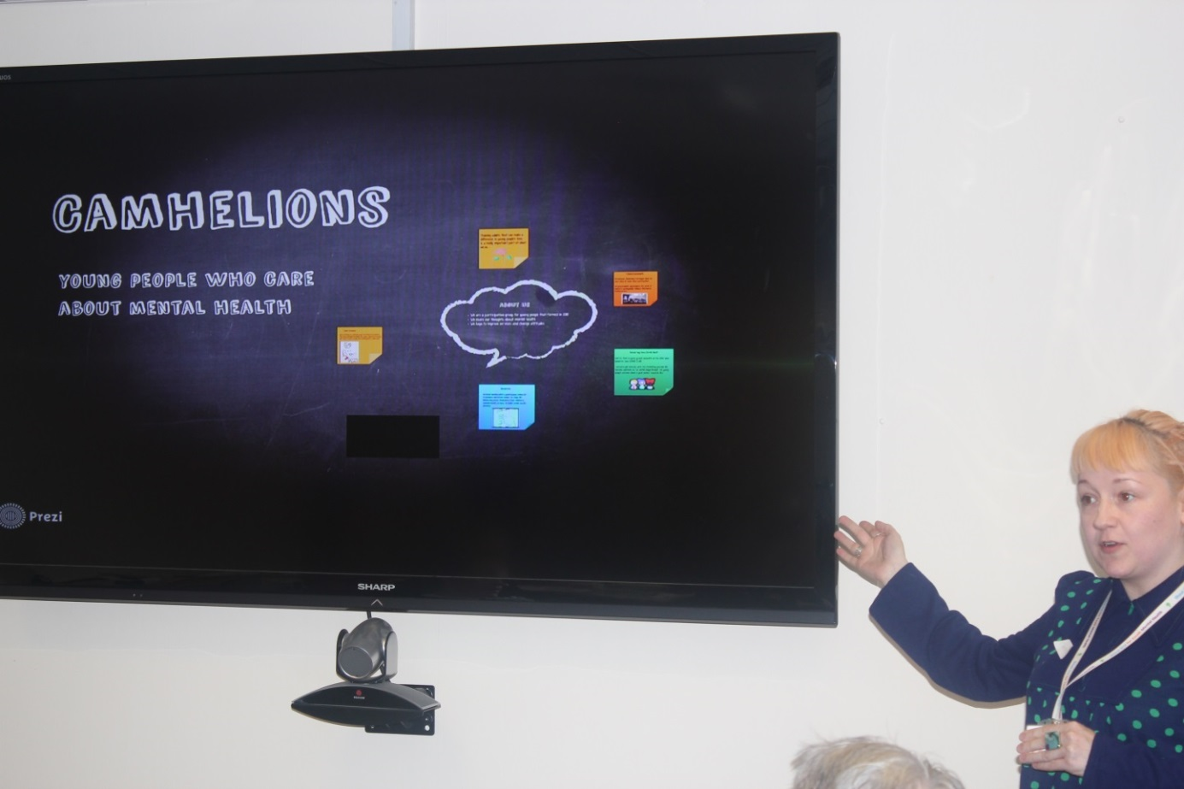

Key themes from workshop discussions
In the workshop, groups were asked to discuss some of the barriers that young people (YP) might face accessing GP appointments. Each group was given a barrier that a YP might face when making or getting to a GP appointment and were asked to explore this in more detail.
The four examples of barriers that were given to the groups were:
- Online access
- Transport to the GP
- Building accessibility
- Budget / money
Using these examples, the groups were asked to fill out four sections to answer the following:
- How does the YP feel about this barrier?
- What are the current resources to reduce the barrier?
- What is the effect of the barrier?
- What is the cause of the barrier, and what would you ideally need to remove the barrier?
The results can be found below:

Barrier: Transport
How does the YP feel about this barrier?  Frustrated  Isolated | What are the current resources to reduce the barrier?  Partially pay the young person’s travel expenses
What is the cause of the barrier, and what would you ideally need to remove the barrier?  Rising travel costs  Cuts to the NHS  An appointment travel card for free travel to the GP or Hospital | What is the effect of the barrier?  Health implications  Missed appointments  Struck off for non-attendance  Depression

Barrier: Having no online access
How does the YP feel about this barrier?  Mistrust in the service  Anxious/nervous about ringing up | What are your current resources to reduce the barrier?  Leaflet & flyer signposting  School Nurse to get more involved  Universities/colleges to give more info to YP  Youth friendly information
What is the cause of the barrier, and what would you ideally need to remove the barrier?  Service not being up to date  Technology not up to date  Have a 24/7 phone line  Easy walk-in service | What is the effect of the barrier?  YP not using services  Can’t access the service 24/7

Barrier: money
How does the YP feel about this barrier?  Loss of ‘Independence’ | What are your current resources to reduce the barrier?
What is the cause of the barrier, and what would you ideally need to remove the barrier?  Training in youth engagement/communication  Virtual consultations  Phone apps (CAMHS)  Improve accessibility of GPs in schools and colleges (reduce travelling costs) | What is the effect of the barrier?  Ongoing health issues

Barrier: No building access

How does the YP feel about this barrier?  Frustrated - letting patients down  Worried  Unsupported  Angry  Excluded  Confused | What are your current resources to reduce the barrier?  Outreach GPs  Extend Surgery Hours  Adaptations to the building (Wheelchair access/lifts)  Info about local public transport
What is the cause of the barrier, and what would you ideally need to remove the barrier?  Accessible building upgrades  Become centrally located  Simplify services  Outreach  One stop shop/hub Model | What is the effect of the barrier?  Don’t receive services/information  At risk  Develop long term health conditions

Summary / next steps
Graham Bayliss, lay member of NHS South Sefton CCG, rounded up the event and fed back to the group that the actions taken from the meeting will be taken to the formal EPEG group in January 2017.
- EPEG will use and promote the top 10 tips for engaging with YP, particularly taking on board the different approaches needed when engaging with YP compared with adults.
- The CCGs chief nurse, Debbie Fagan, said that she would be keen to let the group take over the quality team for a day and this is being explored for 2017.
- The EPEG group will look at developing ideas for how it can work more constructively with vulnerable young people and harder to reach groups.
- Promote the role of EPEG young person’s representative as an avenue to communicate good practice, issues and concerns.
- Use the existing young people’s networks to promote and communicate CCG and health related information e.g. CAS (young people’s website/hub) and Sefton Youth Council Forum.
- CCG and providers have been invited to attend and host a stall at the Young Person’s health and wellbeing event on Tuesday, 21st March (details to follow).
- At the event on the 21st March, EPEG will share the information, outcomes and film from the YP’s EPEG meeting.
- Healthwatch is developing a YP engagement plan with the Young Advisors and will invite EPEG to get involved
- So YP can share their experiences accessing and using local GP services, EPEG will discuss and develop plans on how YP can get more involved in the work of local GP practices.
- The CCG will host an annual young people’s engagement event.

Get involved or find out more
After the event, several people were interviewed about how they found the event and what they got out of it and the videos can be found on the CCGs’ You Tube channels:
- www.youtube.com/playlist?list=PLCn6CMQmsERlSZF5FVGVzpYUrH8Nola5N
- www.youtube.com/playlist?list=PLgoTUaz3ZkhN6Cb-v-f5vbE4sIZWKNM9G
The CCG websites also have details about other ways you can get involved in their work – from attending their Big Chat events to signing up to their database. You can also read about examples of where they have involved people previously in their work.
www.southportandformbyccg.nhs.uk / www.southseftonccg.nhs.uk
If you would like to tell them about your experience of local health services then you can also call 0151 247 7000.
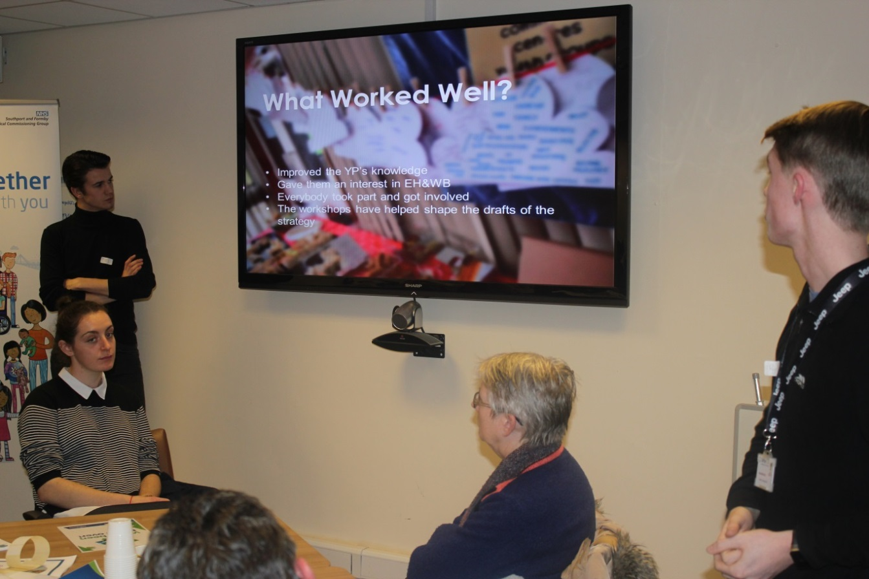

www.southportandformbyccg.nhs.uk
www.southseftonccg.nhs.uk
On request this report can be provided in different formats, such as large print, audio or Braille versions and in other languages.

