|  |  |  |  |  |  |  |
| --- | --- | --- | --- | --- | --- | --- |
| **MEETING OF THE**  **FINANCE AND RESOURCE COMMITTEE**  **February 2017** | | | | | | |
| **Agenda Item:** FR17/28 | | **Author of the Paper:**  Martin McDowell  Chief Finance Officer  Email: [martin.mcdowell@southseftonccg.nhs.uk](mailto:martin.mcdowell@southseftonccg.nhs.uk)  Tel: 0151 247 7065 | | | | |
| **Report date:** February 2017 | |
| **Title:** Financial Position of NHS South Sefton Clinical Commissioning Group – Month 10 | | | | | | |
| **Summary/Key Issues:**  This paper presents the Finance and Resource Committee with an overview of the year to date financial position for NHS South Sefton Clinical Commissioning Group as at 31 January 2017.  Cost pressures continue to affect the position in Month 10 and delivery of the QIPP plan is below target, these factors have led to deterioration in the financial position and year end forecast. The revised forecast is a deficit of £2.332m which reflects known risks and expected delivery of QIPP savings for the remainder of the financial year. The forecast position is dependent on delivery of a further £1.331m QIPP savings as well as mitigation of any further risks. | | | | | | |
|  | | | |  |  |  |
| **Recommendation**  The Finance and Resource Committee is asked to receive this report and take note particularly that:   * Due to emerging pressures, the revised surplus target for the CCG is £1.250m. * The financial position has deteriorated further during the month and the likely outturn position is a deficit of **£2.332m**. The likely position includes the expenditure forecast delivery of QIPP savings for the remainder of the financial year * It should be noted that the forecast deficit does not include the 1% non-recurrent reserve which is held uncommitted as directed by NHS England. * Release of the 1% reserve (£2.432m) will result in a surplus of £0.100m which delivers the CCG statutory financial duty to achieve a break even position. * The CCG is undertaking an urgent and critical review of the remaining QIPP programme areas to provide assurance that the anticipated level of savings can be achieved in the remainder of the financial year. * The CCG’s commissioning team must support member practices in reviewing their commissioning arrangements to identify areas where clinical variation exists, and address accordingly. High levels of engagement and support is required from member practices to enable the CCG to reduce levels of low value healthcare and improve value for money. | | |  | Receive | x |  |
| Approve |  |  |
| Ratify |  |  |
|  |  |  |
|  | | | |  |  |  |
| Links to Corporate Objectives *(x those that apply)* | | | | | | |
| X | To focus on the identification of QIPP (Quality, Improvement, Productivity & Prevention) schemes and the implementation and delivery of these to achieve the CCG QIPP target. | | | | | | |
| X | To progress Shaping Sefton as the strategic plan for the CCG, in line with the NHSE planning requirements set out in the “Forward View”, underpinned by transformation through the agreed strategic blueprints and programmes. | | | | | | |
| X | To ensure that the CCG maintains and manages performance & quality across the mandated constitutional measures. | | | | | | |
| X | To support Primary Care Development through the development of an enhanced model of care and supporting estates strategy, underpinned by a complementary primary care quality contract. | | | | | | |
| X | To advance integration of in-hospital and community services in support of the CCG locality model of care. | | | | | | |
| X | To advance the integration of Health and Social Care through collaborative working with Sefton Metropolitan Borough Council, supported by the Health and Wellbeing Board. | | | | | | |

| **Process** | **Yes** | **No** | **N/A** | **Comments/Detail *(x those that apply)*** |
| --- | --- | --- | --- | --- |
| Patient and Public Engagement | X |  |  | Ongoing public engagement |
| Clinical Engagement | X |  |  |  |
| Equality Impact Assessment |  |  | X |  |
| Legal Advice Sought |  |  | X |  |
| Resource Implications Considered | X |  |  |  |
| Locality Engagement |  | X |  |  |
| Presented to other Committees |  | X |  |  |

|  |  |
| --- | --- |
| Links to National Outcomes Framework *(x those that apply)* | |
| X | Preventing people from dying prematurely |
| X | Enhancing quality of life for people with long-term conditions |
| X | Helping people to recover from episodes of ill health or following injury |
| X | Ensuring that people have a positive experience of care |
| X | Treating and caring for people in a safe environment and protecting them from avoidable harm |

|  |  |
| --- | --- |
| **Report to Finance and Resource Committee**  **February 2017** |  |

1. **Executive Summary**

This report focuses on the financial performance for South Sefton CCG as at 31 January 2017 (Month 10).

The forecast outturn position after the application of reserves is a deficit of **£2.332m** against a planned surplus of £2.450m. The forecast position is subject to delivery of remaining QIPP schemes in 2016/17. Release of the 1% uncommitted non recurrent reserve, currently held uncommitted as directed by NHS England, would achieve a surplus position of £0.100m.

The financial position relating to operational budgets at Month 10, before the application of reserves is £0.588m overspend against plan with a year-end forecast of £1.199m overspend following mitigation of cost pressures with the CCG contingency budget. The forecast position deteriorated by £0.204m during the month, the deterioration during the year relates to increased expenditure forecasts within acute care, underperformance against the QIPP plan and cost pressures relating to the national increase in the costs of Funded Nursing Care.

The QIPP requirement to deliver the planned surplus of £1.250m for the financial year was £10.384m. QIPP delivered at the end of Month 10 is £5.020m and the forecast overspend on operational budgets is £1.199m. The CCG anticipates a further £1.331m worth of savings to be delivered in the remainder of the financial year. The result of all these factors means that the CCG is forecasting a likely position of a £2.332m deficit as highlighted in **Table F**.

The high level CCG financial indicators are listed below in **Table A**.

**Table A – Financial Dashboard**

|  |  |  |  |  |
| --- | --- | --- | --- | --- |
| **Report Section** | **Key Performance Indicator** | | **This Month** | **Prior Month** |
| 1 | Business Rule (Forecast Outturn) | 1% Surplus | **🗸** | **🗸** |
| 0.5% Contingency Reserve | **🗸** | **🗸** |
| 1% Non-Recurrent Headroom | **🗸** | **🗸** |
| 2 | Surplus | Financial Surplus / (Deficit) | **(£2.332m)** | **£1.250m** |
| 3 | QIPP | QIPP Plan delivered – *(Red if shortfall against planned delivery)* | **£5.020m** | **£4.462m** |
| 4 | Running Costs (Forecast Outturn) | CCG running costs < CCG allocation 2016/17 | **🗸** | **🗸** |
| 5 | BPPC | NHS - Value YTD > 95% | **99.97%** | **100.00%** |
| NHS - Volume YTD > 95% | **93.3%** | **93.34%** |
| Non NHS - Value YTD > 95% | **87.60%** | **87.08%** |
| Non NHS - Volume YTD > 95% | **91.91%** | **91.47%** |

1. **Resource Allocation**

Additional allocations have been received in Month 10 as follows:

* Children and Young People Waiting List and Waiting Times - £0.040m

This allocation forms part of the CAMHS transformation funding, was expected and will be spent before the end of the financial year.

1. **Financial Position and Forecast**

The main financial pressures included within the financial position are shown below in **Graph 1** which presents the CCGs forecast outturn position for the year. A full breakdown of the CCG position is detailed in **Appendix 1.**

There are forecast pressures within funded nursing care due to the nationally mandated uplift, and in acute care. Pressures on acute budgets are particularly evident at Alder Hey, Aintree, Liverpool Heart & Chest and in the Independent Sector, mainly with Ramsay Healthcare.

The overspend is supported by underspends with other acute providers, notably Southport & Ormskirk Hospital and Liverpool Women’s Hospital.

It should be noted that whilst the financial report is up to the end of January 2017, the CCG has based its reported position on the latest information received from Acute and Independent providers which is up to the end of December 2016.

**Appendix 2** outlines the financial performance by provider.

**Graph 1**

**Acute commissioning**

**Alder Hey Children’s Hospital Foundation Trust**

The year to date overspend is £0.477m with the prominent areas of overspend being in relation to Paediatrics and Paediatrics ENT of £0.194m and £0.054m respectively. Other notable overspends include a £0.049m adverse pressure in relation to Paediatric Urology, as well as overspends within Paediatric Intensive Care of £0.041m. The forecast position is an overspend of £0.549m for the financial year.

**St Helens & Knowsley Teaching NHS Trust**

The YTD £0.132m overspend at Month 10 includes a £0.115m pressure relating to Plastic Surgery. The year to date position of the 2016/17 contract also highlights a £0.045m overspend due to 2015/16 over performance, as well an over performance caused by T&O which has an adverse year to date pressure of £0.023m. The forecast for the financial year is an overspend of £0.149m.

**Southport & Ormskirk Hospital Trust**

The variance for Southport & Ormskirk Hospital is a £0.293m underspend at Month 10 with a year-end forecast of a £0.352m underspend. There is a £0.210m year to date underspend against Trauma & Orthopaedics, as well as underspends in Obstetrics and A&E of £0.126m and £0.062m respectively. These are offset by an overspend of £0.136m in General Medicine. This is shown in the three graphs below.

**Graph 2**

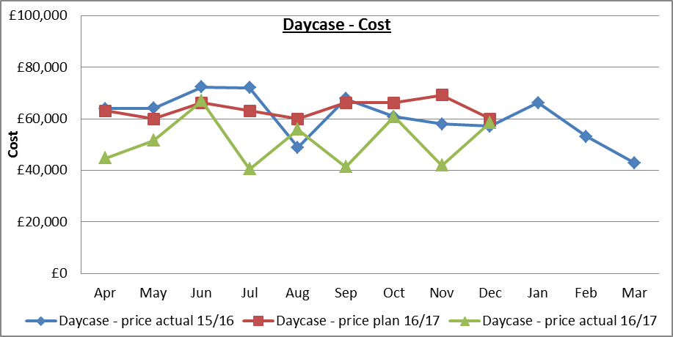

**Graph 3**

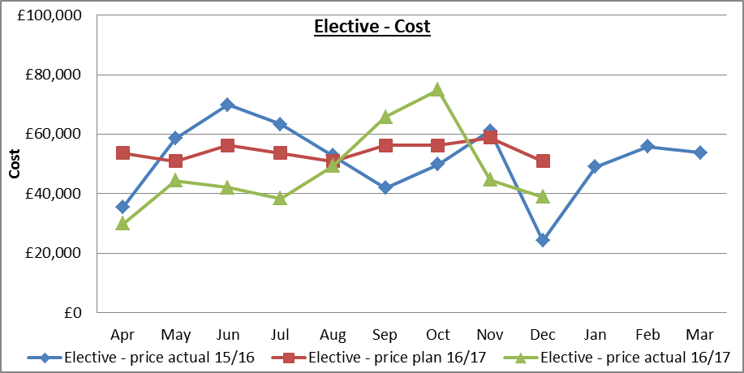

**Graph 4**

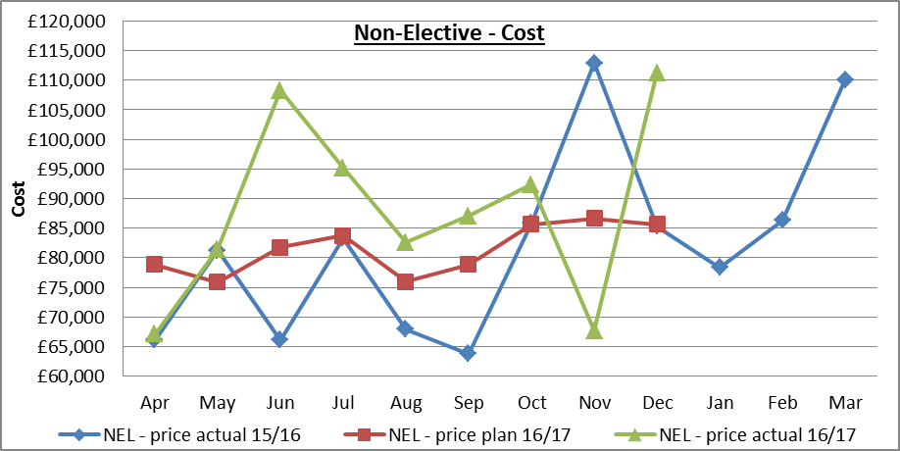

**Graph 5**

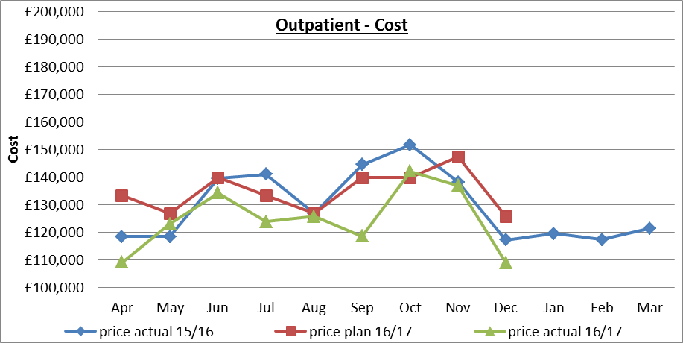

**Aintree University Hospital Foundation Trust**

The overspend reported for Aintree is £0.187m year to date with a year-end forecast of £0.755m. This position is based on the agreed year-end settlement with Aintree.

The year to date position is based on Month 9 performance information received from the trust and has been extrapolated to Month 10 position. The newly opened urgent care treatment centre, with a revised layout, has contributed to the increased costs.

This overspend is predominantly within Cardiology £0.471m, Acute Medicine £0.411m, Gastroenterology £0.378m and Clinical Haematology £0.190m. This is offset by underspends within Elective and Non-Elective Accident & Emergency £1.084m, Geriatric Medicine £0.443m and Respiratory Medicine £0.289m.

In-depth analysis of the activity data is continuously being undertaken and findings are discussed with the provider. The CCG will agree formal challenges to be raised within contracted timescales for areas that are currently over performing against plan.

**Graph 6**

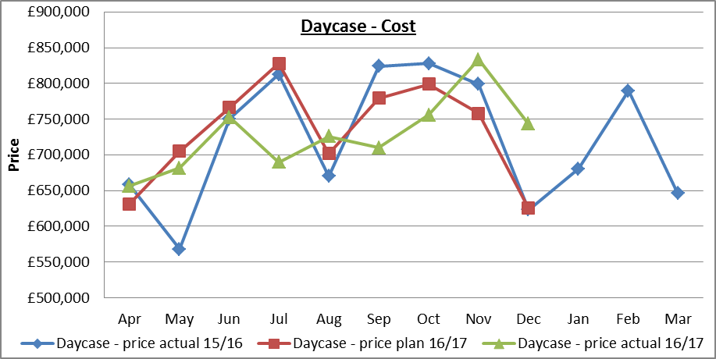

**Graph 7**

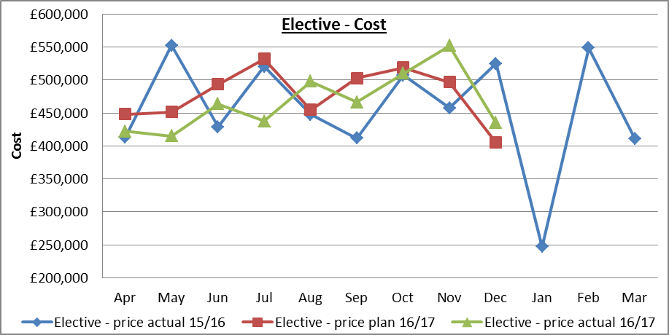

**Graph 8**

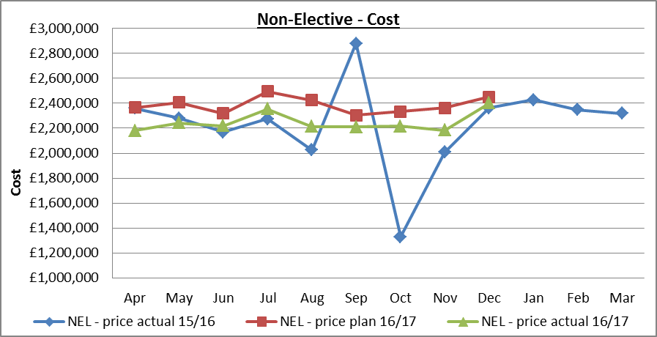

**Graph 9**

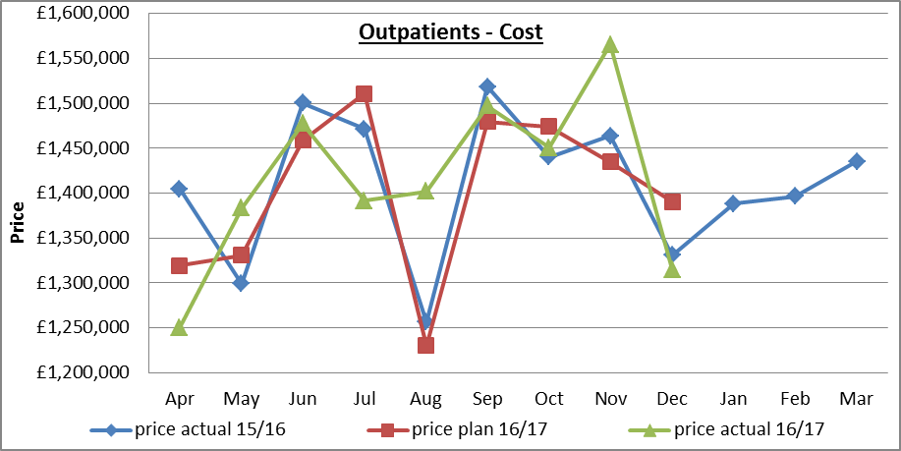

**Independent Sector**

The year to date position on the budget for Independent Sector is an overspend of £0.471m mainly due to Ramsay Healthcare experiencing an over performance against plan. The year-end forecast is an overspend of £0.636m. The majority of the overspend relates to Ramsay Healthcare in respect of Trauma and Orthopaedic activity over performance against plan.

**Prescribing**

The year to date position on the prescribing budget is an underspend of £0.126m after adjusting for QIPP savings of £0.360m. The year-end forecast is breakeven.

**Appendix 6** provides reconciliation to the forecast presented in the prescribing report.

**Continuing Health Care and Funded Nursing Care**

The year to date position for the continuing care and funded nursing care (FNC) budget is an overspend of £0.699m, which reflects the current number of patients, average package costs, the nationally mandated FNC increase (£0.745m) and an uplift to CHC providers of 1.1% until the end of the financial year which has been communicated.

Year to date QIPP savings have been actioned against this budget to the value of £1.025m, relating to the additional growth budget of 5% included at budget setting and other efficiencies relating to prior year charges. The forecast financial position is taken following this budget reduction, and has been included in the QIPP plan for 2016/17.

The full year forecast is an overspend of £1.048m mainly due to the increased costs in respect to Funded Nursing Care of £0.745m. These costs are included within the CCG forecast position.

1. **QIPP**

The 2016/17 identified QIPP plan is **£10.384m.** This plan has been phased across the year on a scheme by scheme basis and full detail of progress at scheme level is monitored at the QIPP committee.

**Table B** shows a summary of the current risk rated QIPP plan approved at the Governing Body in May 2016. This demonstrates that although recurrently there are a significant number of schemes in place, further work is being done to determine whether they can be delivered in full. The detailed QIPP plan is shown in Appendix 3 and is projected to deliver **£6.351m** in total during the year.

**Table B: RAG rated QIPP plan**



As shown in **Table C** and **Graph 8** below, £5.020m has been actioned at Month 10 against a phased plan of £8.253m.

**Graph 8: Phased QIPP performance for the year**

**Table C: QIPP performance at Month 10**



QIPP delivery is **£3.233m** below plan at Month 10, largely in respect of the urgent care scheme. Although Non Elective costs have reduced compared to plan it is difficult to attribute these to specific schemes.

A critical review of outstanding schemes has been undertaken and an assessment of expected delivery for the remainder of the financial year. The CCG expects to deliver a further **£1.331m** in Months 11 and 12, scheme leads in particular, must work to ensure delivery of the identified schemes. **Table D** below shows the expected delivery of QIPP schemes for the remainder of the financial year.

**Table D – QIPP Schemes to be delivered**



Total QIPP delivery is anticipated to be £6.851m for the financial year which is an underperformance of £4.033m against the original plan of £10.384m. The underperformance, together with an overspend on operational budgets has led to a deterioration in the forecast from a planned surplus of £2.450m to a deficit of £2.332m.

1. **CCG running costs**

The running cost allocation for the CCG is £3.259m andthe CCG must not exceed this allocation in the financial year.

The current year end outturn position for the running cost budget is an underspend of £0.224m.

1. **CCG Cash Position**

In order to control cash expenditure within the NHS, limits are placed on the level of cash an organisation can utilise in each financial year.

The Maximum Cash Drawdown (MCD) is the maximum amount of cash available to a CCG each financial year and is made up of:

* Total Agreed Allocation
* Opening Cash Balance (i.e. at 1st April 2016)
* Opening creditor balances less closing creditor balances

Cash is held centrally at NHS England and is allocated monthly to CCGs following notification of cash requirements.

As well as managing the financial position, organisations must manage their cash position. The monthly cash requested should cover expenditure commitments as they fall due and the annual cash requested should not exceed the maximum cash drawdown limit.

The CCG is required to take part in an MCD submission to NHS England at months 6 and 9 to incorporate any changes in the CCGs forecast cash position to ensure sufficient cash is available throughout the financial year. An increase in MCD cannot always be accommodated.

**Month 10 position**

Following the month 9 submissions the MCD limit for South Sefton CCG for 2016/17 was increased from £241.032m to £249.742m. Up to Month 10, the actual cash received is £205.205m (82.2% of MCD) against a target of £208.119m (83.3% of MCD).

A full year cash flow forecast, based on information available at month 10, has been produced and included in **Appendix 4** below. This shows the CCG will have sufficient cash to meet its liabilities as they fall due. At month 12, the CCG is required to meet a cash target of 1.75% of its monthly cash drawdown (approximately £320k) as detailed below the CCG is forecasting to meet this target.

The CCG has been notified by NHS England that there is no opportunity prior to the year end to request additional cash above the MCD level of £249.742m. As a result of the finance team having to maintain this cash position, this could potentially result in an increase in year-end creditors and deterioration in BPPC performance.

An overview of the run rate for the CCG is provided in **Appendix 5** which shows the actual spend each month for the year to date.

1. **Compliance with the BPPC target**

The NHS is required to adhere to the Better Payment Practice Compliance Target (BPPC) as part of the wider public sector responsibility to ensure that it fulfils its role as a good corporate citizen. The full year performance is reported in the CCG annual report and subject to scrutiny by the external auditors.

Cumulative performance for the year to date is below the 95% target for all areas, except payments to NHS providers by value. BPPC Performance is detailed in **Graphs 9 and 10** below. The drop in performance seen in Graph 10 for Non NHS creditors relates directly to the Quarter 4 2015/16 BCF invoice which was paid one week later than scheduled.

**Graph 10** shows a reduction in performance for non-NHS value, this is due to a small number of high value invoices not approved within the required timescale due to system downtime.

|  |  |
| --- | --- |
|  |  |

**Graph 9 Graph 10**

1. **Evaluation of risks and opportunities**

The primary financial risk for the CCG continues to be non-delivery of the QIPP target in the financial year. The forecast position is dependent on delivery of £1.331m QIPP schemes in the remainder of the financial year.

There are also a number of other risks that require ongoing monitoring and managing:

* Acute contracts – The CCG has experienced significant growth in acute care year on year, and this trend has continued in the current financial year. Further risk in relation to over performance at Aintree has been mitigated with an agreed year end position. There remains risk on other NHS contracts in respect of quarter 4 performance.

All members of the CCG have a role to play in managing these risks including GPs and other Health professionals to ensure individuals are treated in the most clinically appropriate and cost effective way to ensure that the acute providers are charging correctly for the clinical activity that is undertaken. This is continually reviewed during the financial year.

* Prescribing - This is a volatile area of expenditure but represents one of the biggest opportunities for the CCG, and as such this makes up a significant element of the QIPP programme for 2016/17. The monthly expenditure and forecast is monitored closely as QIPP schemes continue to be delivered.

**1% Non-Recurrent reserve**

As part of NHS England business rules for 2016/17 CCGs were required to set aside 1% (£2.432m) uncommitted funds non-recurrently. The CCG is expecting these funds to be released within the financial year.

1. **Reserves budgets / Risk adjusted surplus**

Reserve budgets are set aside as part of the Budget Setting exercise to reflect planned investments, known risks and an element for contingency. Each month, the reserves and risks are analysed against the forecast financial performance and QIPP delivery.

The assessment of the financial position is set out in **Table E** below. This demonstrates that the CCG plans to deliver a total management action plan of £6.351m in 2016/17 which will result in a deficit of £2.332m.

In order to deliver the CCG statutory duty to break even, the CCG is reliant on return of the 1% non-recurrent reserve, which remains uncommitted as directed by NHS England. It is anticipated that this funding will be released to the CCG late in the financial year and is expected to improve the CCG’s financial position from £2.332m deficit to £0.100m surplus.

Delivery of the remaining QIPP plan is challenging and requires co-operation with partners across the healthcare economy. The CCG has allocated GP Governing Body member leads to each QIPP programme along with executive leads, and the leads meet on a monthly basis to report progress against their own programme to the Senior Team.

**T able E – Forecast Outturn Position**

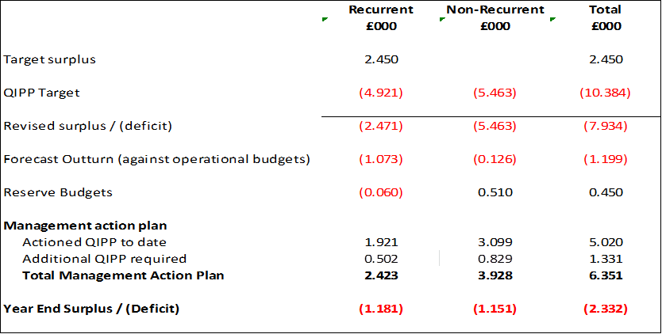

**Table F** below outlines the best, most likely and worst case scenarios. The best case scenario assumes achievement of the remaining risk adjusted QIPP plan plus further delivery of £0.200m.

The most likely case is a deficit of £2.332m which assumes delivery of the remaining risk adjusted QIPP plan.

The worst case scenario assumes achievement of the remaining risk adjusted QIPP plan and increased risk in respect of Acute Care.

**Table F – Risk Rated Financial Position**



1. **Recommendations**

The Finance and Resource Committee is asked to receive the finance update, noting that:

* The CCG agreed a revised surplus target of £1.250m with NHS England at month 6. Financial pressures have continued to emerge in year and the revised surplus target for the CCG is £1.250m.
* The financial position has deteriorated further during the month and the likely outturn position is a deficit of **£2.332m**. The likely position includes the expenditure forecast delivery of QIPP savings for the remainder of the financial year
* It should be noted that the forecast deficit does not include the 1% non-recurrent reserve which is held uncommitted as directed by NHS England.
* Release of the 1% reserve (£2.432m) will result in a surplus of £0.100m which delivers the CCG statutory financial duty to achieve a break even position.
* The CCG is undertaking an urgent and critical review of the remaining QIPP programme areas to provide assurance that the anticipated level of savings can be achieved in the financial year.
* The CCG’s commissioning team must support member practices in reviewing their commissioning arrangements to identify areas where clinical variation exists, and address accordingly. High levels of engagement and support is required from member practices to enable the CCG to reduce levels of low value healthcare and improve value for money.

**Appendices**

Appendix 1 – Financial position - Month 10

Appendix 2 – Provider breakdown

Appendix 3 – 2016/17 QIPP plan

Appendix 4 – Cash flow Forecast

Appendix 5 – Run Rate

Appendix 6 - Prescribing Budget Reconciliation

**Appendix 1 – Financial Position Month 10**



**Appendix 2 – Detailed Breakdown of Provider Costs**





**Appendix 3 – 2016/17 QIPP Plan**





**Appendix 4 – Cash Flow Forecast**

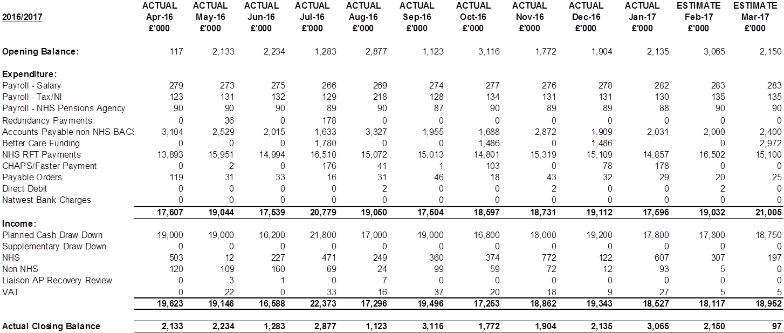

**Appendix 5 – CCG Run Rate**









**Appendix 6**

**Prescribing Budget Reconciliation**

